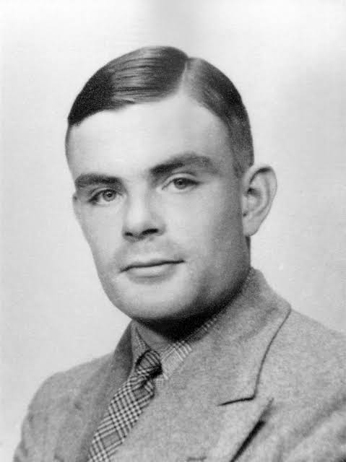***Alan Turing***

in full Alan Mathison Turing, (born June 23, 1912, London, England—died June 7, 1954, Wilmslow, Cheshire), British mathematician and logician, who made major contributions to mathematics, cryptanalysis, logic, philosophy, and mathematical biology and also to the new areas later named computer science, cognitive science, artificial intelligence, and artificial life.

**Early Life & Career**

The son of a civil servant, Turing was educated at a top private school. He entered the University of Cambridge to study mathematics in 1931. After graduating in 1934, he was elected to a fellowship at King’s College (his college since 1931) in recognition of his research in probability theory. In 1936 Turing’s seminal paper “On Computable Numbers, with an Application to the Entscheidungsproblem [ Decision Problem]” was recommended for publication by the American mathematical logician Alonzo Church, who had himself just published a paper that reached the same conclusion as Turing’s, although by a different method. Turing’s method (but not so much Church’s) had profound significance for the emerging science of computing. Later that year Turing moved to Princeton University to study for a Ph.D. in mathematical logic under Church’s direction (completed in 1938).

**Code Breaker**

Having returned from the United States to his fellowship at King’s College in the summer of 1938, Turing went on to join the Government Code and Cypher School, and, at the outbreak of war with Germany in September 1939, he moved to the organization’s wartime headquarters at Bletchley Park, Buckinghamshire. A few weeks previously, the Polish government had given Britain and France details of the Polish successes against Enigma, the principal cipher machine used by the German military to encrypt radio communications. As early as 1932, a small team of Polish mathematician-cryptanalysts, led by Marian Rejewski, had succeeded in deducing the internal wiring of Enigma, and by 1938 Rejewski’s team had devised a code-breaking machine they called the Bomba (the Polish word for a type of ice cream). The Bomba depended for its success on German operating procedures, and a change in those procedures in May 1940 rendered the Bomba useless. During the autumn of 1939 and the spring of 1940, Turing and others designed a related, but very different, code-breaking machine known as the Bombe. For the rest of the war, Bombes supplied the Allies with large quantities of military intelligence. By early 1942 the cryptanalysts at Bletchley Park were decoding about 39,000 intercepted messages each month, a figure that rose subsequently to more than 84,000 per month—two messages every minute, day and night. In 1942 Turing also devised the first systematic method for breaking messages encrypted by the sophisticated German cipher machine that the British called “Tunny.” At the end of the war, Turing was made an Officer of the Most Excellent Order of the British Empire (OBE) for his code-breaking work.

**Artificial Intelligence Pioneer**

Turing was a founding father of artificial intelligence and of modern cognitive science, and he was a leading early exponent of the hypothesis that the human brain is in large part a digital computing machine. He theorized that the cortex at birth is an “unorganised machine” that through “training” becomes organized “into a universal machine or something like it.” Turing proposed what subsequently became known as the Turing test as a criterion for whether an artificial computer is thinking (1950).